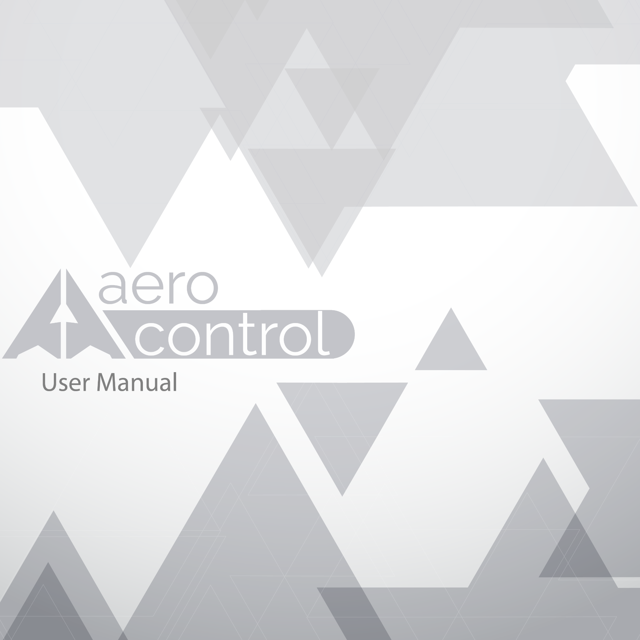

# Introduction

In this manual we pretend to guide in the use of the platform AeroControl. In it contain we will see the aspects more essentials to use in an easy way the platform. AeroControl is an application that was design with the objective to innovate the form of many airlines work in just one platform. AeroControl, is an application Web also offers the function of buy tickets, and also allow print the list of all registers in the platform and consult the different ways.

Modules

**Administrator:** This type of module have all the actions inside the platform, it can inter flights, sign up Airlines, users. Clients, etc. This manage all the system from its own platform.



**User Client:** This type of module only have the option to buy flights and see the different destinations.



**Airline:** The Airlines have the option to post their flights, and post the promotions that have inside the platform.

# Platform administrator (Screenshots)

* First we sign in the principal page of AeroControl or we sign up (If we don’t have an account) as we can see in the next forms that appear in the image.

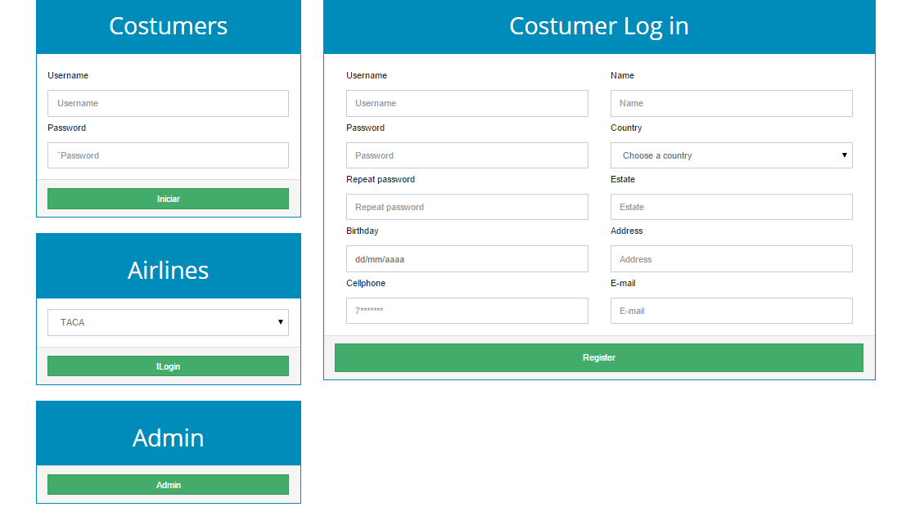

Now that you login, it will appear all the flights that are available to buy.

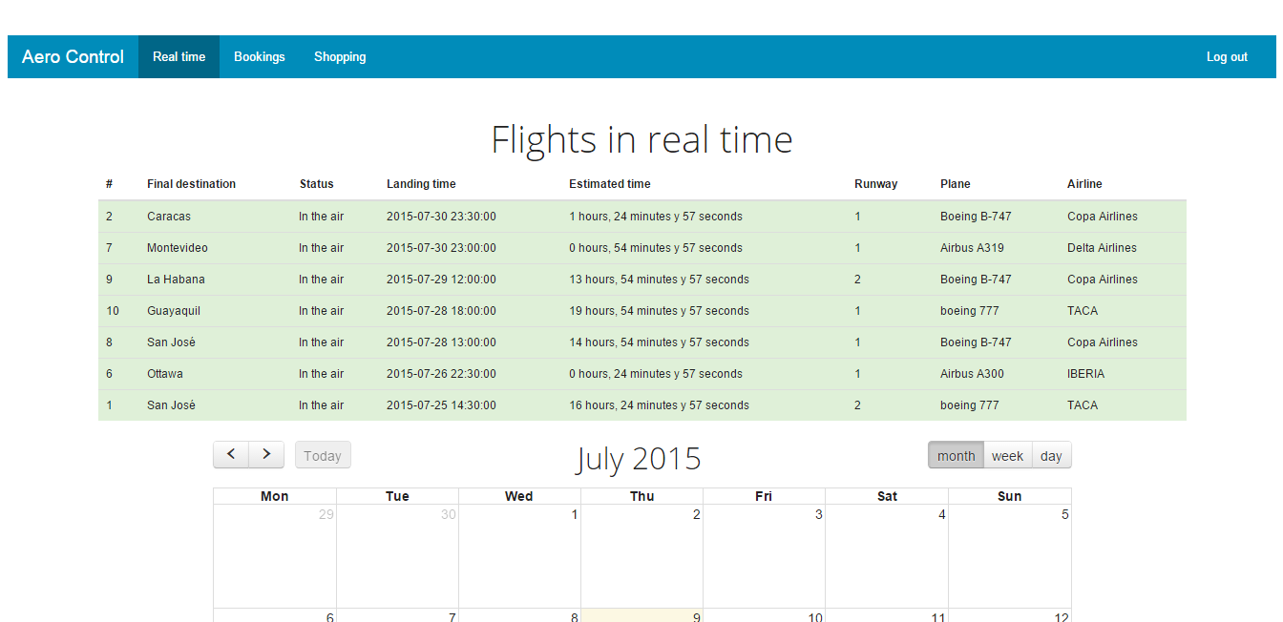

Also we can see a calendar with a description and the departure date of the flights.

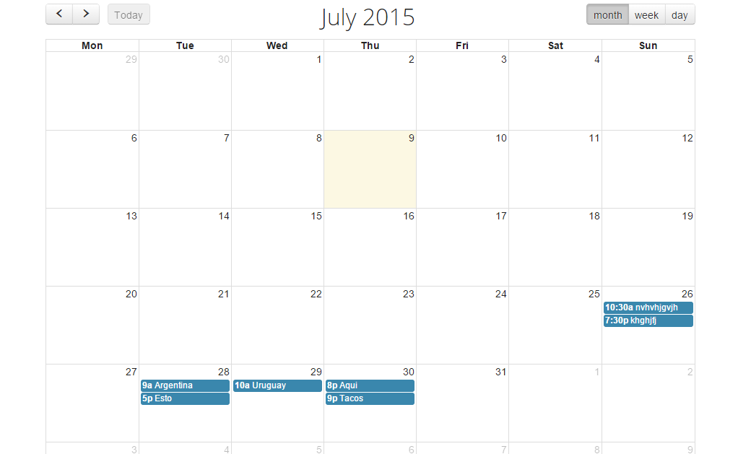

In the part of booking we can search for your preference to all the flights that are available to buy. 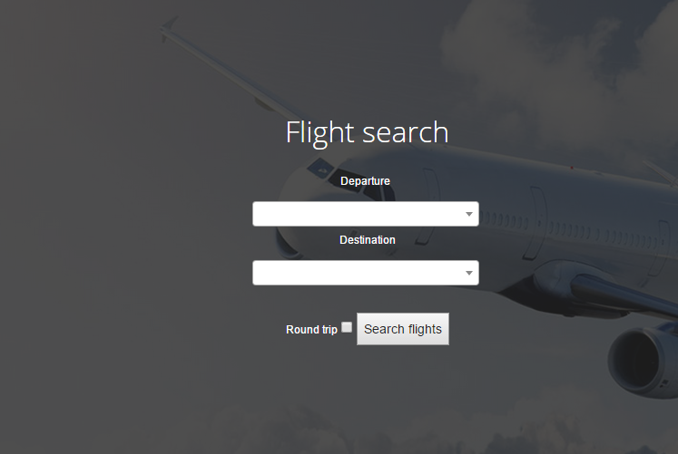

You have to different types for search.

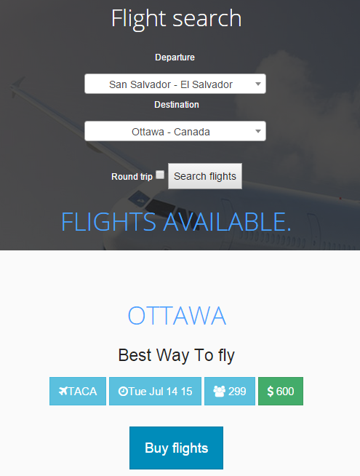

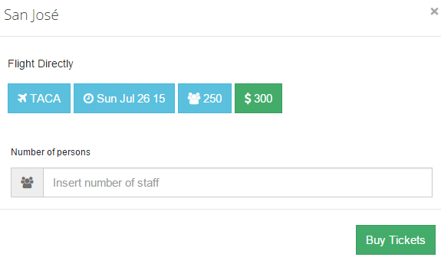When you want to buy tickets it will appear this form that you have to complete.

If all if okay it will show this message.

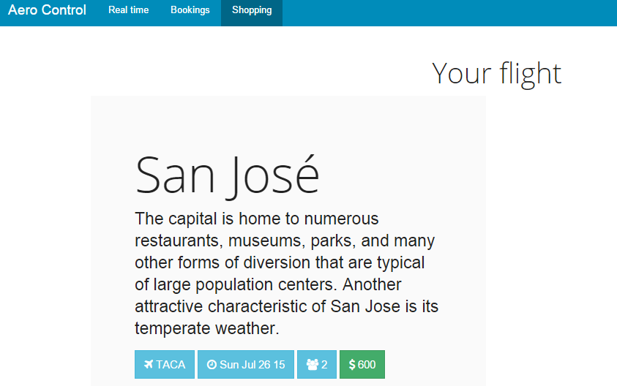And in booking it will appear all the flights that we buy in the platform.

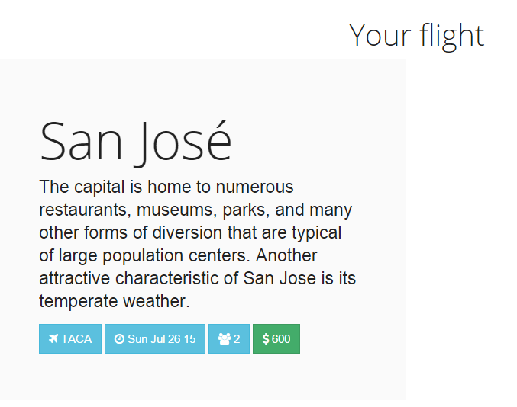

Airline Price

Day Number of seats

# Glossary

Airline: An organization that provides air transportation for passengers and freight.

Airplane: Any of various winged vehicles capable of flight, generally heavier than air and driven by jet engines or propellers.

Airports: a tract of land or water with facilities for the landing, takeoff, shelter, supply, and repair of aircraft, especially one used for receiving or discharging passengers and cargo at regularly scheduled times.

Staff: a group of persons, as employees, charged with carrying out the work of an establishment or executing some undertaking.

Flight: The motion of an object in or through a medium, especially through the earth's atmosphere or through space.

Destinations: the place to which a person or thing travels or is sent.

Tickets: a slip, usually of pap.er or cardboard, serving as evidence that the holder has paid a fare or admission or is entitled to some service, right, or the like.

Client: A customer or patron.

Calendar: a table or register with the days of each month and week in a year.

Administrator: One who administers, especially one who works as a manager in a business, government agency, or school.

Stewardess: A woman flight attendant.

Passport: An official document issued by a government identifying a citizen, certifying his or her nationality, and formally requesting admittance and safe passage from foreign countries.

Seats: something designed to support a person in a sitting position, as a chair, bench, or pew; a place on or in which one sits.

Zip: to travel with a sharp hissing or humming sound.

Runways: A strip of level, usually paved ground on which aircraft take off and land.

Location: a place of settlement, activity, or residence.

Aircraft: is a machine that is able to fly by gaining support from the air, or, in general, the atmosphere of a planet.

Cost: An amount paid or required in payment for a purchase; a price.

State: The supreme public power within a sovereign political entity.

Database: is an organized collection of data.

PHP : is a script language and interpreter that is freely available